**E-COMMERCE PRODUCT PAGE**

**NAZAA -ONLINE STORE**

STEP 1: Login page

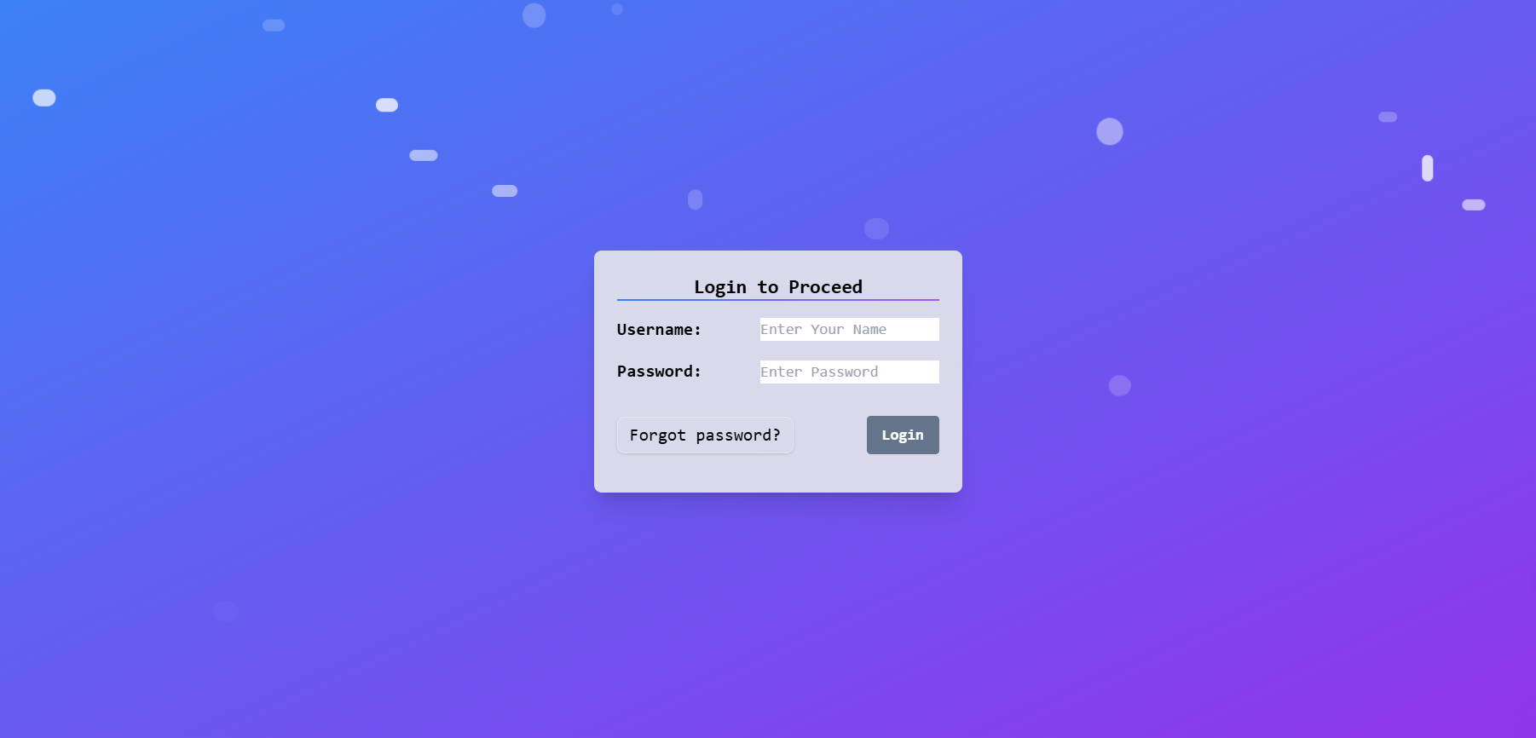

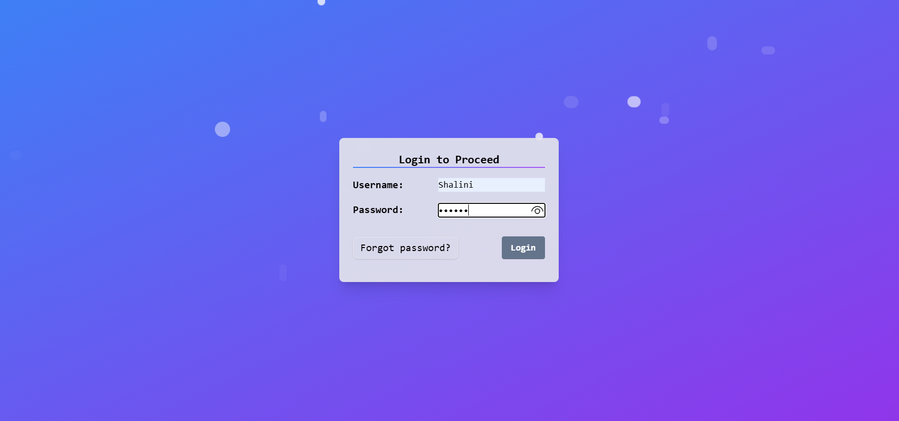

* Only admins can add products. Regular users do not have permission to perform this action (Admin – Shalini).

STEP 2: Home Page



STEP3: Product Page

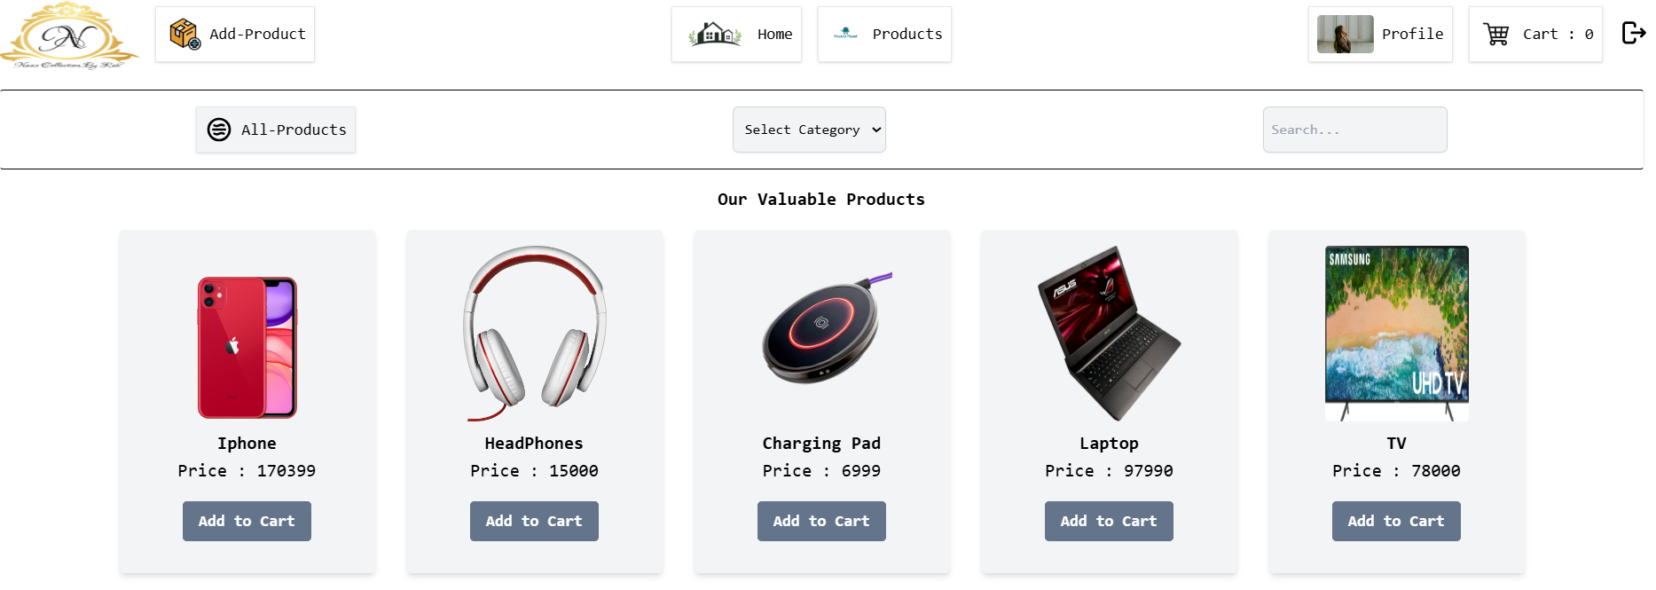

* We can search for products, and if you select a category, the search will be limited to that category only. Additionally, you can add items to your cart.



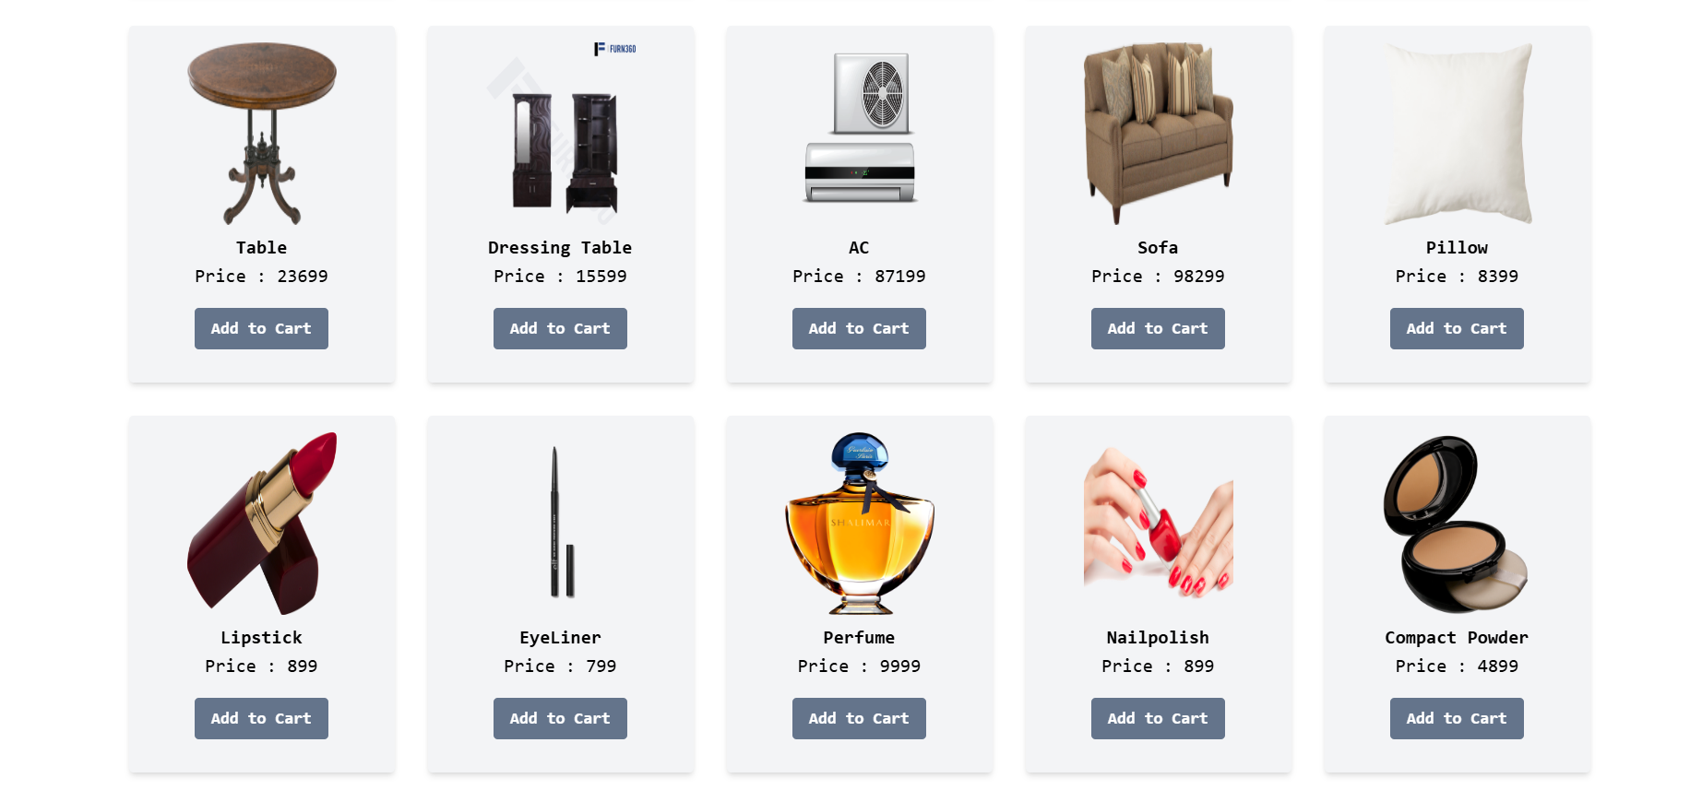

* Filtering on Category: Beauty Products

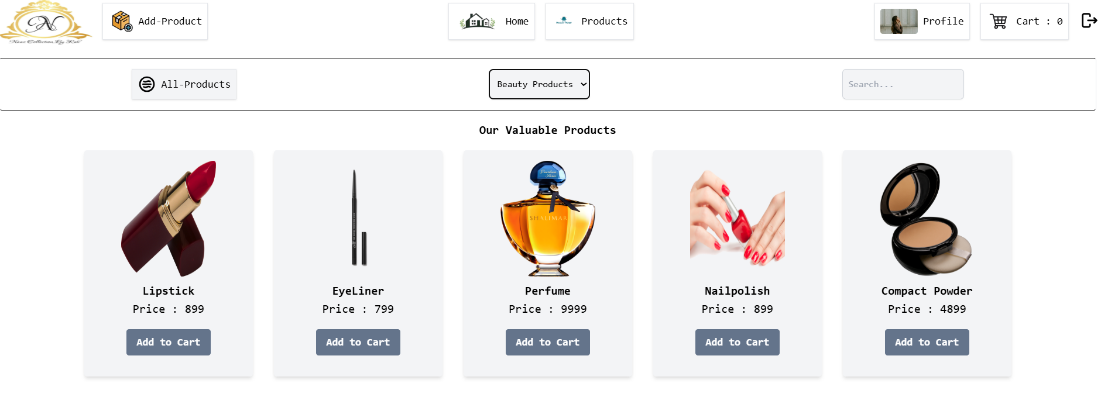

* Electronics:

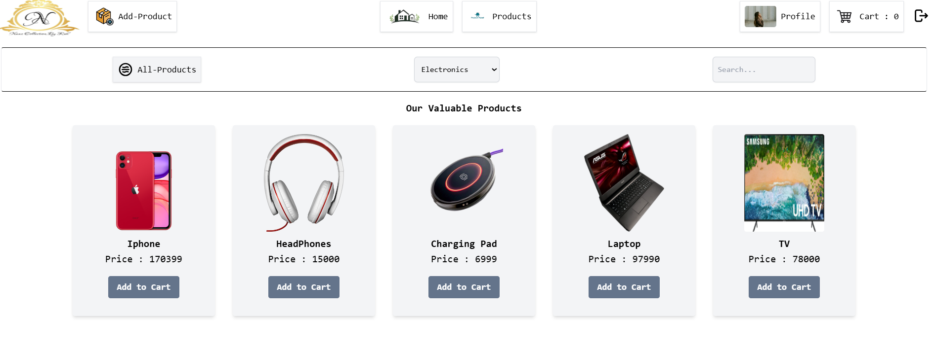

* Fashion:

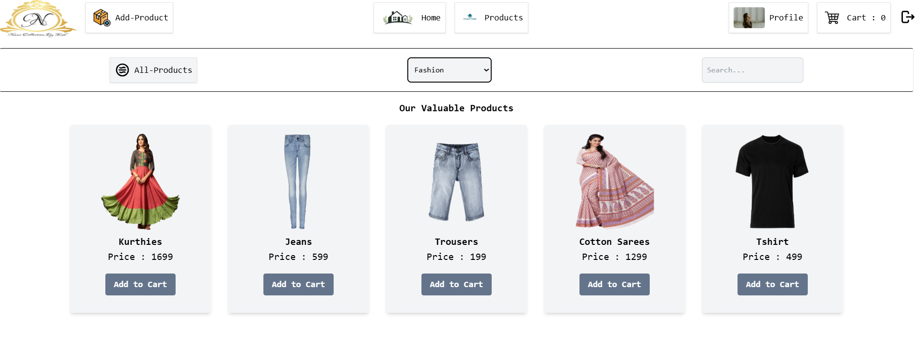

* Home Goods:

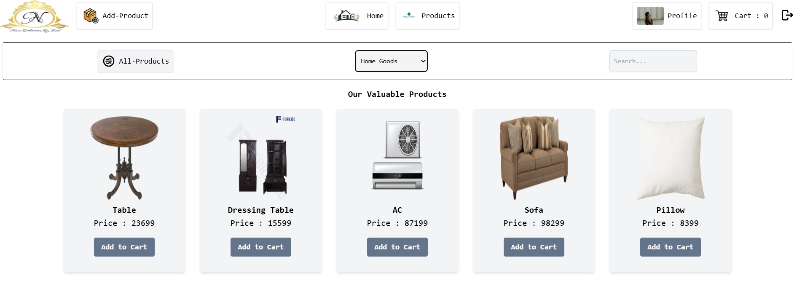

* The searching is based on the category only.

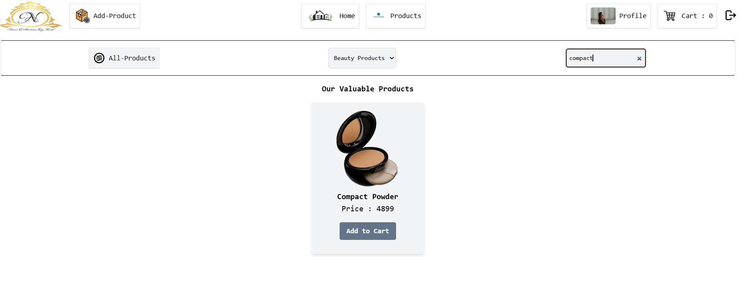

STEP 4: Adding items to the cart.

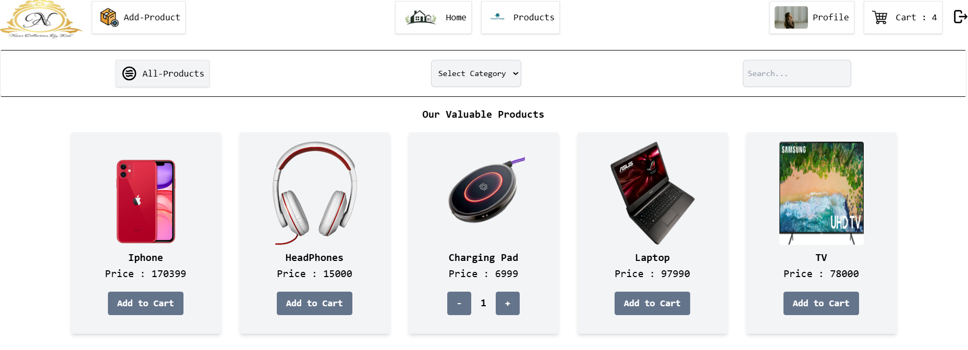

* Currently, there are 4 items in the cart after selecting the desired products.

STEP 5: Cart Page

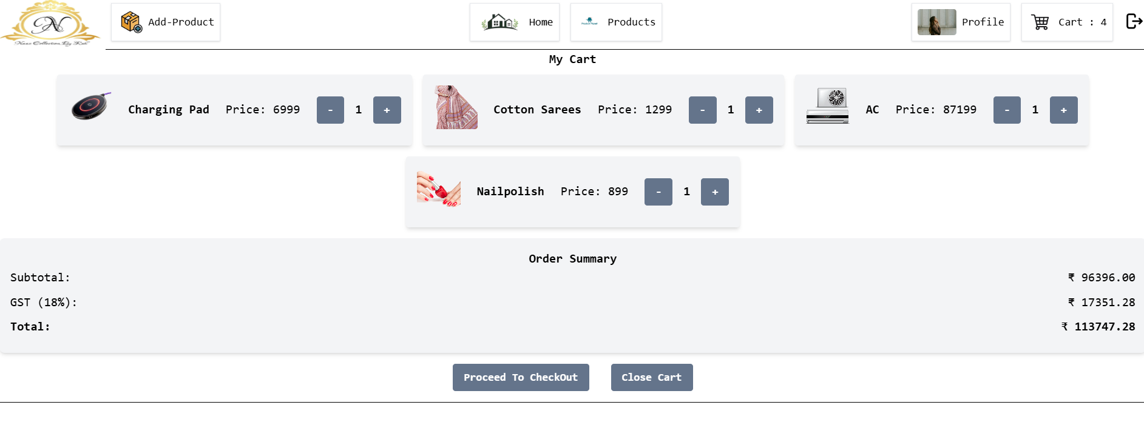

* We can remove items from the cart by clicking the negative (minus) icon (Removing Charging Pad).

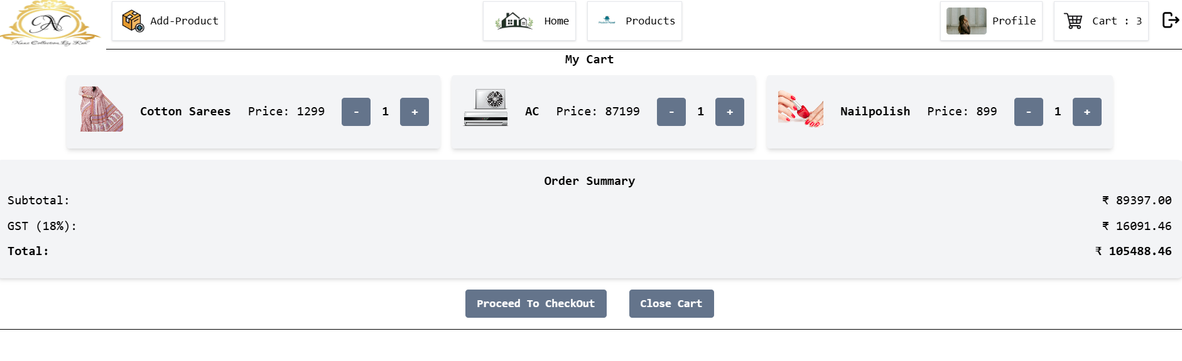

* The price updates based on the selected items, and an 18% GST is applied.
* There is a logout icon that allows users to log out of their account.

STEP 6: Adding Products (Only admin)

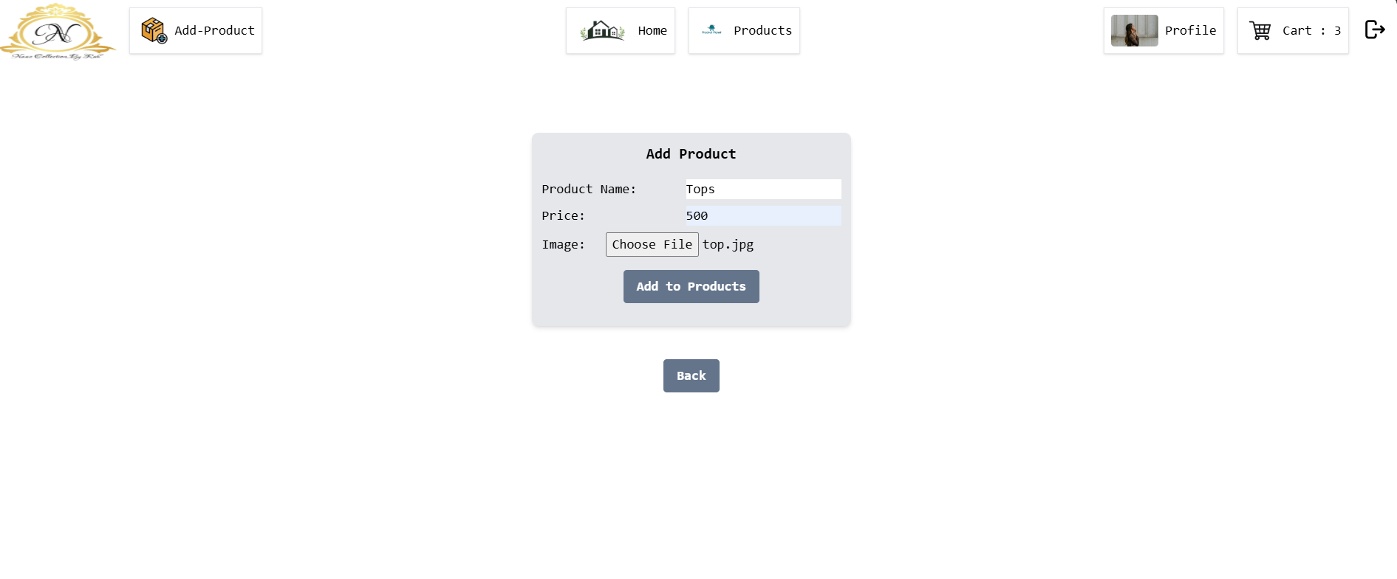

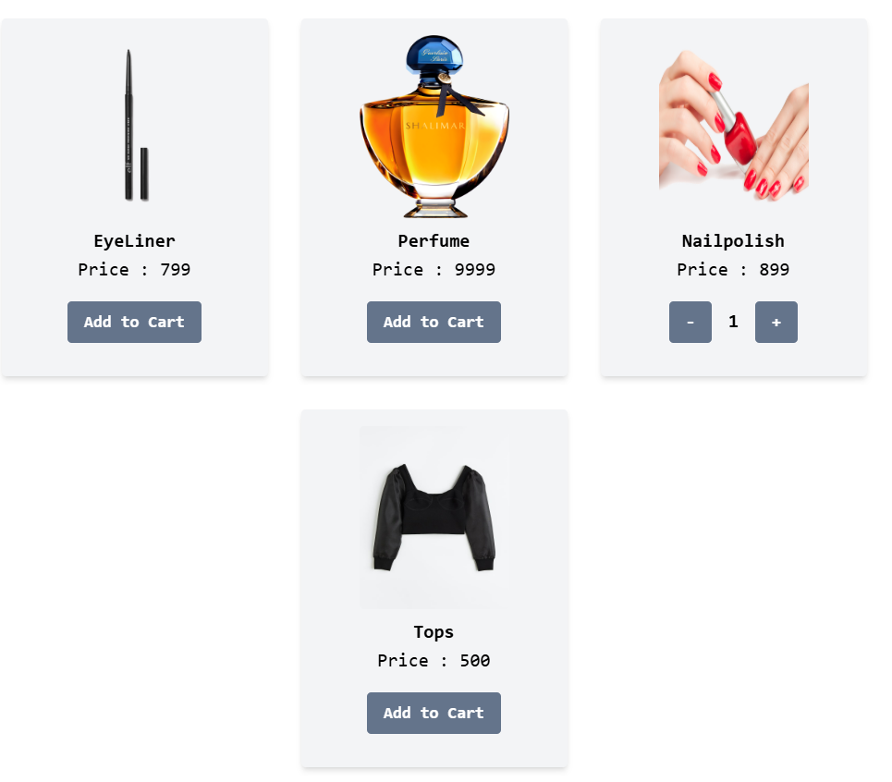

* Finally, the top is added to the product list.

STEP 7: USER

* Profile Page:

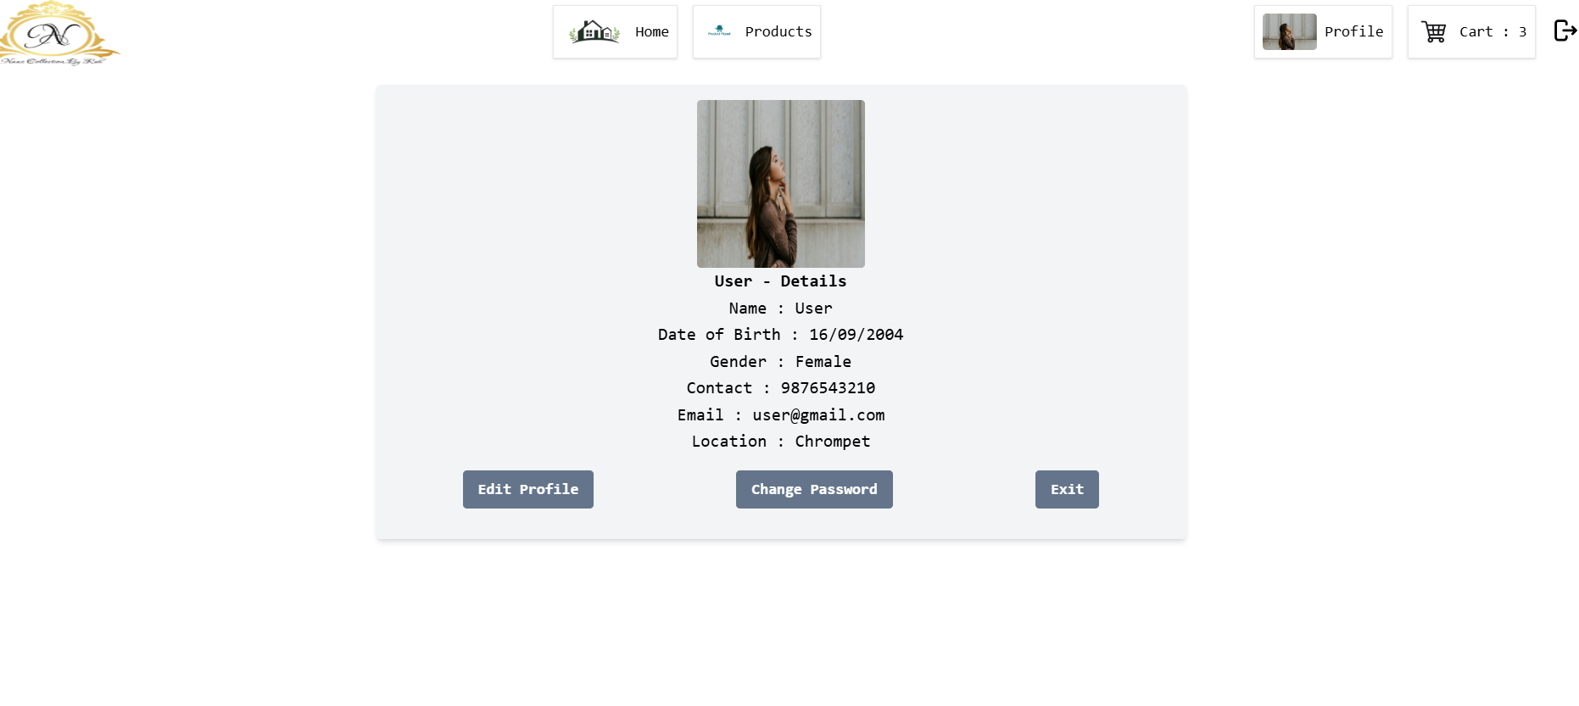

* No add product option:



**Animation, Tailwind CSS, React Router, and React.js**

**1. Animation**

**Overview**

Animation enhances the user experience by adding motion effects to UI elements. In React, animations can be implemented using different techniques.

**Methods of Animation**

* **CSS Animations & Transitions**: Utilize @keyframes and transition properties.
* **Tailwind CSS Animations**: Predefined utility classes like animate-bounce and animate-fade.
* **Framer Motion**: A powerful React library for animations.
* **GSAP (Greensock Animation Platform)**: A robust JavaScript animation library.
* **Lottie**: Used for rendering vector animations from JSON-based files.

**2. Tailwind CSS**

**Overview**

Tailwind CSS is a utility-first CSS framework that helps in quickly designing modern and responsive user interfaces.

**Key Features**

* **Utility-Based Styling**: Eliminates the need for writing custom CSS.
* **Responsive Design**: Uses sm, md, lg, xl for breakpoints.
* **Dark Mode Support**: dark:bg-gray-800 enables dark mode styling.
* **Customization**: Configurable via tailwind.config.js.

**3. React Router**

**Overview**

React Router is a library for managing navigation in React applications.

**Features**

* **Client-side Routing**: No full page reloads.
* **Dynamic Routes**: Define paths dynamically.
* **Nested Routes**: Organize component structure efficiently.
* **Protected Routes**: Restrict access to specific pages.
* **URL Parameters & Query Strings**: Pass dynamic data via URLs.

**4. React.js**

**Overview**

React.js is a JavaScript library used for building interactive user interfaces.

**Key Features**

* **Component-Based Architecture**: UI is built using reusable components.
* **Virtual DOM**: Efficient updates and rendering.
* **Hooks**: Functions like useState, useEffect manage state and side effects.
* **Props & State**: Used for data handling in components.
* **JSX Syntax**: A combination of HTML and JavaScript.

This document provides a structured overview of **Animation, Tailwind CSS, React Router, and React.js**, helping developers understand and implement these technologies effectively.